BIU action item

1. Configurable size of command and queues.
Command queue: 1/2/4
Data queue: 1/cacheline

- One input pin syn-asyn (1:syn; 0: asyn) to select either sync or async mode in NDS_BIU_SYNC_ASYN configuration.

- While crossing level one boundary, HPTWK only issues a single word transaction. No prefetching is needed.

- Indicates the minimum latency of read cycle into read waveform. And minimum latency of grant protocol waveform.

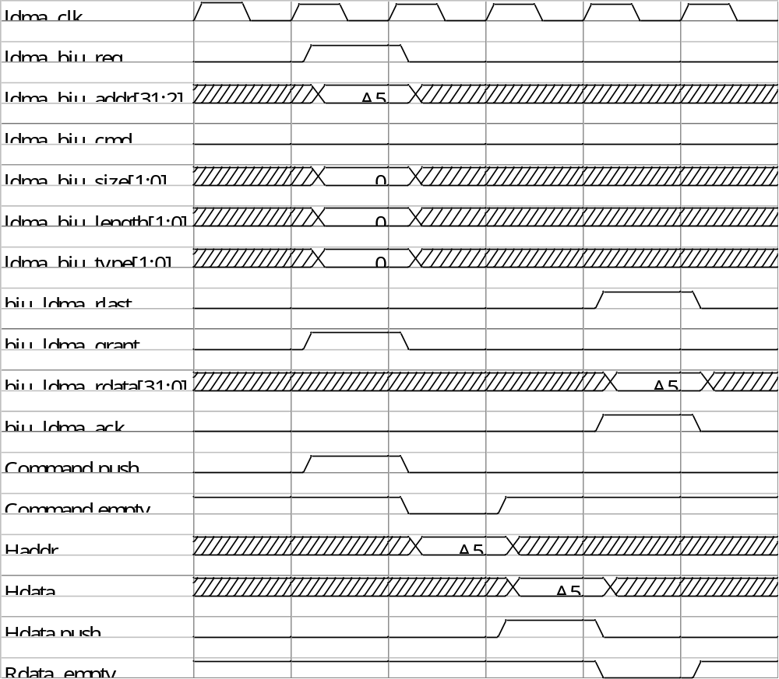
- FCU kill protocol waveform

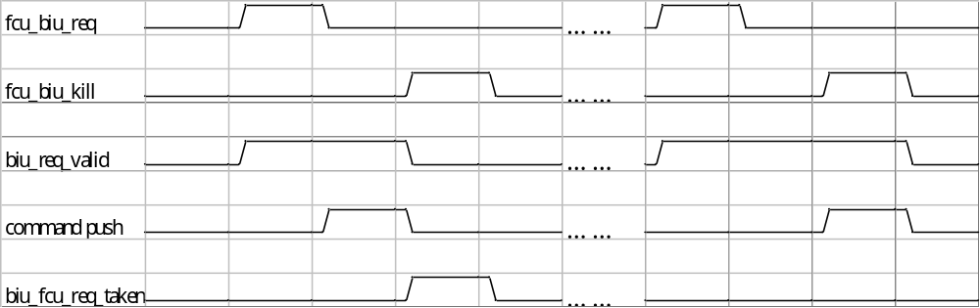
6. Rename clock name to core_clk.
See interface description.

7. Change state transaction from IDLE to ADDR when granted.

See state machine

8 . Explain the function of non_seq_1d..

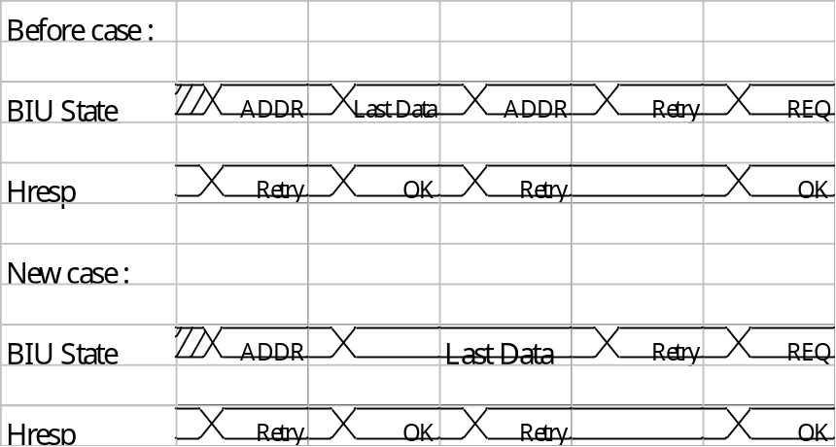

Due to AMBA has back to back feature. So in before case, the first state ADDR doesn’t response Hresp = Retry. Because that is belong to last transaction.

And in new case . There hasn’t ADDR state between transaction. So non_seq_1d is useless.

9. !hgrant & hready & !cmd_fifo_empty is go LAST_DATA or LAST_DATA2.

!hgrant & hready & !cmd_fifo_empty go LAST_DATA

- Retry is go REQ or ADDR.

Retry is go REQ.

- Htrans timing check.

Htrans timing is ok.

- Check BIU request piority

BIU request priority is the same as whitiger.

- biu_req_taken change to biu_req_valid.

- Update retry waveform.

- Write data queue is one depth or 4 depth by hardware configuration.

- Check whitiger AHBx2 configuration.

One AHB receives Icache and Hptwk command. The other AHB receives on others .

In condor , one AHB receives Icache and LDMA to Icache , the other AHB receives on others.

